**Logistic Regression**

* Logistic regression is a statistical model that in its basic form uses a logistic function to model a binary dependent variable, although many more complex extensions exist. In regression analysis, logistic regression is estimating the parameters of a logistic model (a form of binary regression).
* Logistic model has a dependent variable with two possible values, such as pass/fail which is represented by an indicator variable, where the two values are labelled "0" and "1".

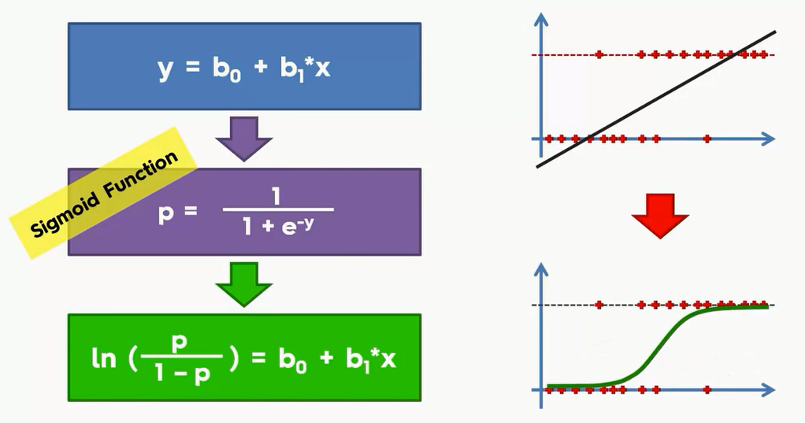

* The above diagram shows how it converted simple linear regression formulas into logistic regression formula, with a result showing 1 or 0.

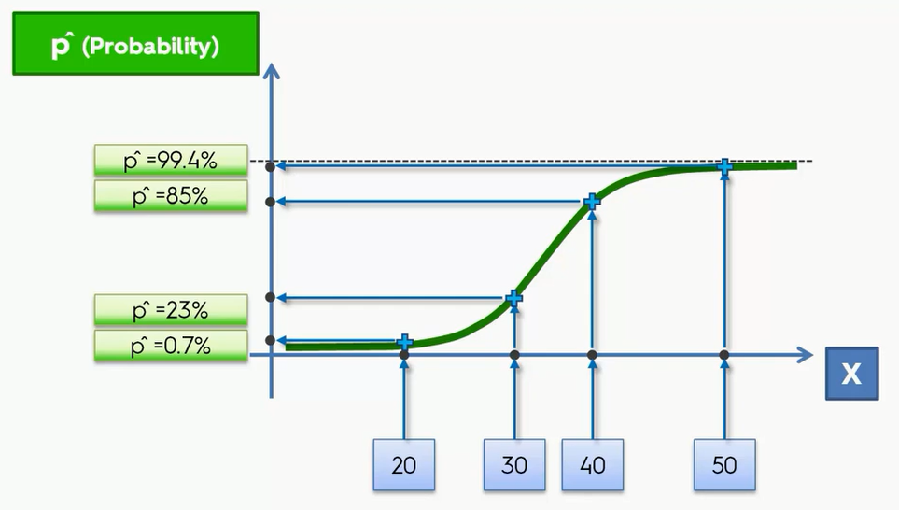

* If we take any example in logistic regression, where it uses probability score such as the result will be either 1 or 0.

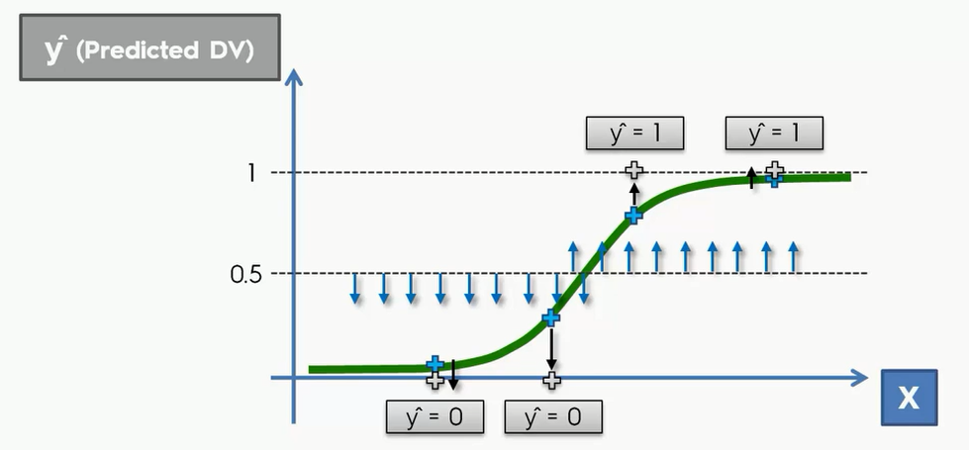

* In the above diagram shows how we implement the process of logistic regression.
* Firstly we should take a line, it can 50% or any value of our priority.
* The lines below shows 0.5 states that the probability which is not interested or (no) or less than what the required probability.
* The lines above 0.5 are interested one’s or (yes) or happened to be required probable one’s.
* The result will be like where any action taken or not depending on the example.

**Dataset-**

Social_networks_ads.csv

* Imagine its a car company. The data scientist mission is to predict the previous customers will buy brand new suv created by your company.
* The car company released the brand new suv and general manager asked data scientist to predict which customers will buy the suv with the highest conversion rate.
* Dataset consist of 3 columns [age, salary, purchased]. Where purchased is dependent variable.